COMPUTER SCIENCE DEPARTMENT

Total Marks: 7.5

Obtained Marks:

LAB: Artificial Intelligence
Project : Hospital Management System

Submitted To: Mam Mutahra Khalid Butt
Date of Submission: 25-December-2025

Project Members
S.NO | Student Name | Reg.no
01 | Ubaid Bin Waris | 2212416
02 | Mushahid Hussain | 2212408
03 | Muhammad Salman | 2212400
04 | Saifullah Shaukat | 2212411

Introduction
The Hospital Management System (HMS) is a Python-based software designed to manage the day-to-day operations of a hospital efficiently.
In most hospitals, record keeping is done manually — which is time-consuming, prone to errors, and difficult to maintain over long periods.
This project aims to develop a digital system that automates hospital operations such as patient registration, doctor information management, appointment scheduling, and billing.
The system will be user-friendly and can be used by hospital receptionists, doctors, and administrators to quickly access and manage hospital information.
Problem Statement
In many small and medium-sized hospitals, patient records, doctor schedules, and billing details are still managed manually using registers or spreadsheets.
This manual process creates several problems such as difficulty in finding or updating old records, chances of data duplication and errors, and poor management of appointments.
It also causes delays in billing and report generation.
To solve these issues, there is a need for a computerized Hospital Management System that can store, manage, and retrieve information easily while ensuring accuracy, security, and efficiency in hospital operations.
Objectives
The key objectives of this project are as follows:
- Automation: Reduce manual work by automating hospital operations.
- Data Management: Efficiently store, update, and retrieve patient and doctor records.
- Appointment Scheduling: Manage appointments between patients and doctors systematically.
- Billing and Reports: Generate patient bills and hospital reports quickly and accurately.
- Ease of Use: Provide a simple and interactive interface for hospital staff.

Scope of the Project
The Hospital Management System will be developed as a Python-based standalone application.
The project will focus on the following functionalities:
- Registration and management of patients and doctors.
- Scheduling and viewing appointments.
- Generating bills for patients.
Literature Review
Hospital Management Systems have been widely adopted in modern healthcare environments to improve efficiency and reduce operational costs. Existing systems often include features such as electronic health records, appointment scheduling, billing, and reporting. Large-scale hospitals use complex web-based or cloud-based systems, while small hospitals require lightweight and cost-effective solutions.
This project focuses on developing a simple yet effective system suitable for small and medium-sized hospitals. Python and SQLite are chosen due to their simplicity, reliability, and ease of implementation

Implementation Plan:

Patient Management
- Allows staff to register new patients with details like name, age, gender, contact number, and patient ID.
- Provides features to view, search, and update patient details.
- Automatically generates a unique ID for each patient.

B. Doctor Management
- Stores information about doctors such as name, specialization, and contact details.
- Helps in assigning doctors to patients and scheduling consultations.
- Allows searching and listing of doctors based on specialization.

C. Appointment Management
- Schedules appointments between patients and doctors.
- Displays the date, time, and purpose of the appointment.
- Allows updating the appointment status (Scheduled, Completed, Cancelled).
- Helps doctors manage their daily appointment lists.

D. Billing Management
- Calculates consultation and treatment charges for patients.
- Generates bills with patient ID, doctor name, total amount, and payment status.
- Maintains a record of paid and unpaid bills for easy tracking.

E. Reporting
- Provides summary reports such as:
  - Total number of patients and doctors.
  - Daily appointment schedules.
  - List of unpaid bills.
- Helps management analyze hospital performance and financial records.
Main Code:
import patient, doctor, appointment, billing, reports
while True:
print("""
1. Add Patient
2. View Patients
3. Add Doctor
4. View Doctors
5. Add Appointment
6. View Appointments
7. Generate Bill
8. View Bills
9. Reports
0. Exit
""")
choice = input("Enter choice: ")
if choice == "1": patient.add_patient()
elif choice == "2": patient.view_patients()
elif choice == "3": doctor.add_doctor()
elif choice == "4": doctor.view_doctors()
elif choice == "5": appointment.add_appointment()
elif choice == "6": appointment.view_appointments()
elif choice == "7": billing.generate_bill()
elif choice == "8": billing.view_bills()
elif choice == "9": reports.summary()
elif choice == "0": break
else: print("Invalid choice")

OUTPUT:
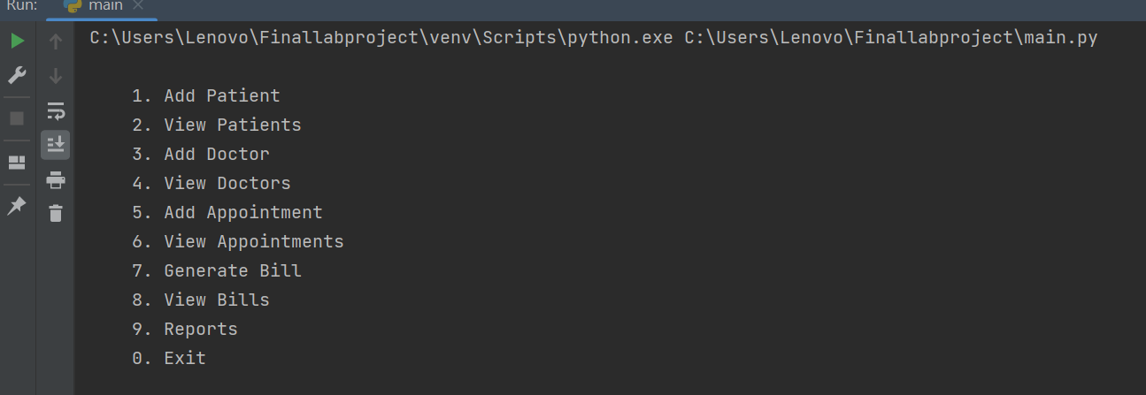
DATABASE:’
import sqlite3
conn = sqlite3.connect("hospital.db")
cursor = conn.cursor()
cursor.execute("""
CREATE TABLE IF NOT EXISTS patients (
patient_id INTEGER PRIMARY KEY AUTOINCREMENT,
name TEXT,
age INTEGER,
gender TEXT,
contact TEXT
)
""")
cursor.execute("""
CREATE TABLE IF NOT EXISTS doctors (
doctor_id INTEGER PRIMARY KEY AUTOINCREMENT,
name TEXT,
specialization TEXT,
contact TEXT
)
""")
cursor.execute("""
CREATE TABLE IF NOT EXISTS appointments (
appointment_id INTEGER PRIMARY KEY AUTOINCREMENT,
patient_id INTEGER,
doctor_id INTEGER,
date TEXT,
time TEXT,
status TEXT
)
""")
cursor.execute("""
CREATE TABLE IF NOT EXISTS bills (
bill_id INTEGER PRIMARY KEY AUTOINCREMENT,
patient_id INTEGER,
doctor_name TEXT,
amount REAL,
payment_status TEXT
)
""")
conn.commit()
conn.close()

ADD PATIENT AND VIEW PATIENT:
import sqlite3
def add_patient():
name = input("Name: ")
age = int(input("Age: "))
gender = input("Gender: ")
contact = input("Contact: ")
conn = sqlite3.connect("hospital.db")
cursor = conn.cursor()
cursor.execute("INSERT INTO patients VALUES (NULL,?,?,?,?)",
(name, age, gender, contact))
conn.commit()
conn.close()
print("Patient added successfully.")
def view_patients():
conn = sqlite3.connect("hospital.db")
cursor = conn.cursor()
cursor.execute("SELECT * FROM patients")
for row in cursor.fetchall():
print(row)
conn.close()

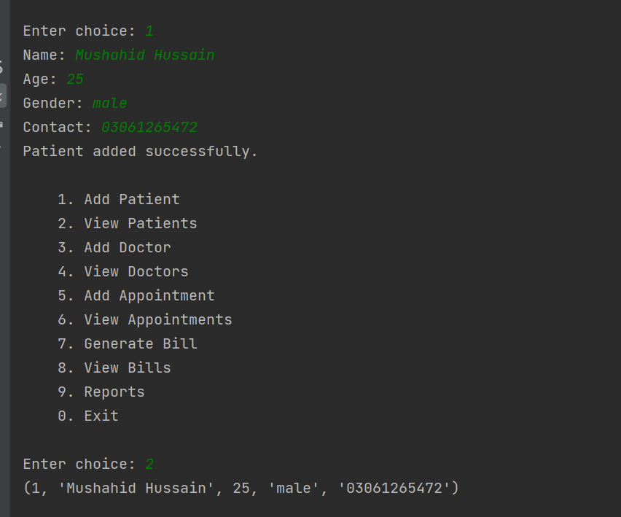
ADD DOCTOR AND VIEW DOCTOR:
import sqlite3
def add_doctor():
name = input("Doctor Name: ")
spec = input("Specialization: ")
contact = input("Contact: ")
conn = sqlite3.connect("hospital.db")
cursor = conn.cursor()
cursor.execute("INSERT INTO doctors VALUES (NULL,?,?,?)",
(name, spec, contact))
conn.commit()
conn.close()
print("Doctor added.")
def view_doctors():
conn = sqlite3.connect("hospital.db")
cursor = conn.cursor()
cursor.execute("SELECT * FROM doctors")
for row in cursor.fetchall():
print(row)
conn.close()

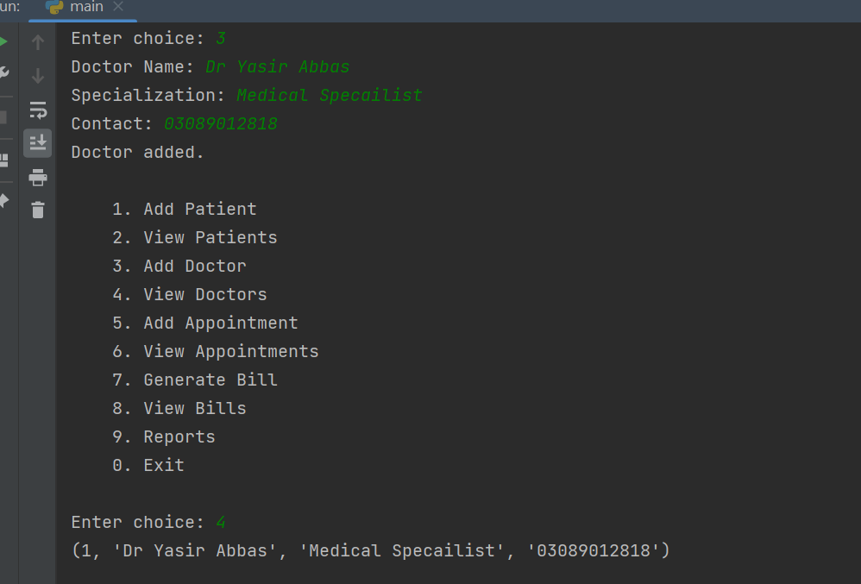
ADD APPOINTMENT AND VIEW APPOINTMENT:
import sqlite3
def add_appointment():
pid = int(input("Patient ID: "))
did = int(input("Doctor ID: "))
date = input("Date (YYYY-MM-DD): ")
time = input("Time: ")
conn = sqlite3.connect("hospital.db")
cursor = conn.cursor()
cursor.execute("""
INSERT INTO appointments VALUES (NULL,?,?,?,?,?)
""", (pid, did, date, time, "Scheduled"))
conn.commit()
conn.close()
print("Appointment scheduled.")
def view_appointments():
conn = sqlite3.connect("hospital.db")
cursor = conn.cursor()
cursor.execute("SELECT * FROM appointments")
for row in cursor.fetchall():
print(row)
conn.close()

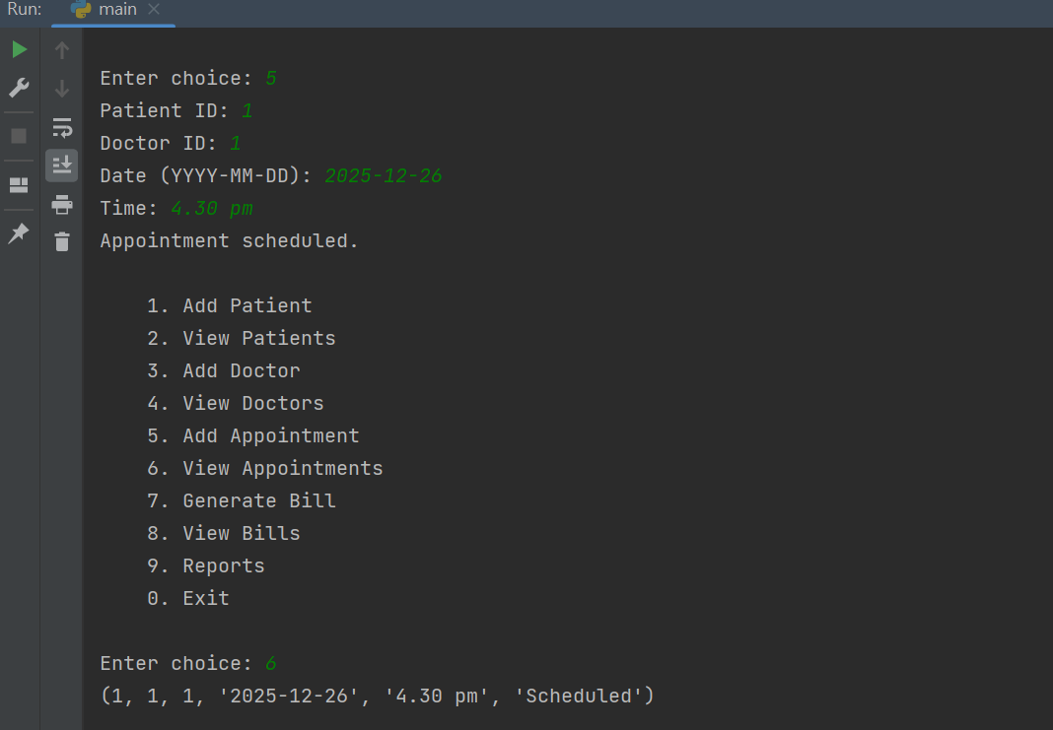
GENERATE BILL AND VIEW BILL:
import sqlite3
def generate_bill():
pid = int(input("Patient ID: "))
doctor = input("Doctor Name: ")
amount = float(input("Amount: "))
conn = sqlite3.connect("hospital.db")
cursor = conn.cursor()
cursor.execute("""
INSERT INTO bills VALUES (NULL,?,?,?,?)
""", (pid, doctor, amount, "Unpaid"))
conn.commit()
conn.close()
print("Bill generated.")
def view_bills():
conn = sqlite3.connect("hospital.db")
cursor = conn.cursor()
cursor.execute("SELECT * FROM bills")
for row in cursor.fetchall():
print(row)
conn.close()

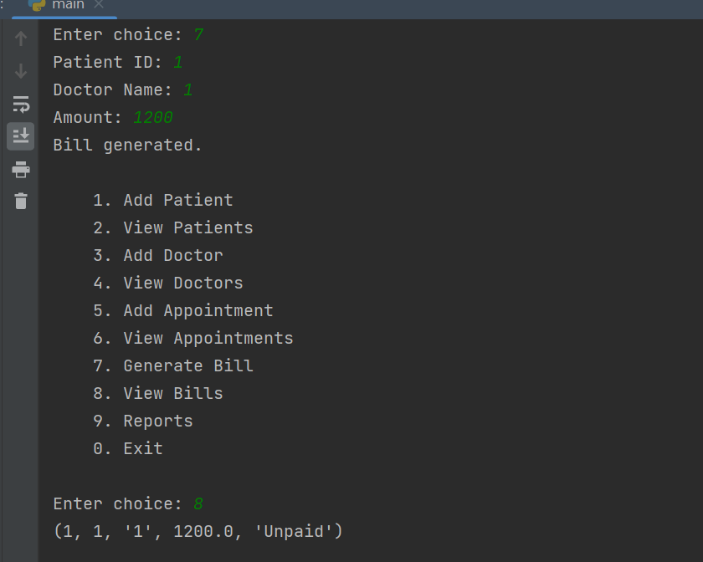

REPORTS:
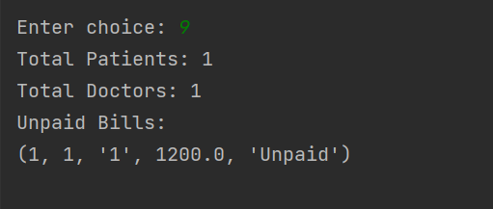

Conclusion
The Hospital Management System provides a simple, efficient, and scalable solution for managing hospital operations digitally.
It replaces outdated manual systems with an automated and accurate record-keeping process.
Built using Python, this system will enhance hospital efficiency, save time, and minimize human errors.
It also serves as an excellent learning project demonstrating practical use of programming, data handling, and problem-solving skills.

